Name: Linta Affaf.

Lab no 5

Function with array , recursion function , pointers

**Qno1:**Write a program that stores 10 values in array and display minimum value?

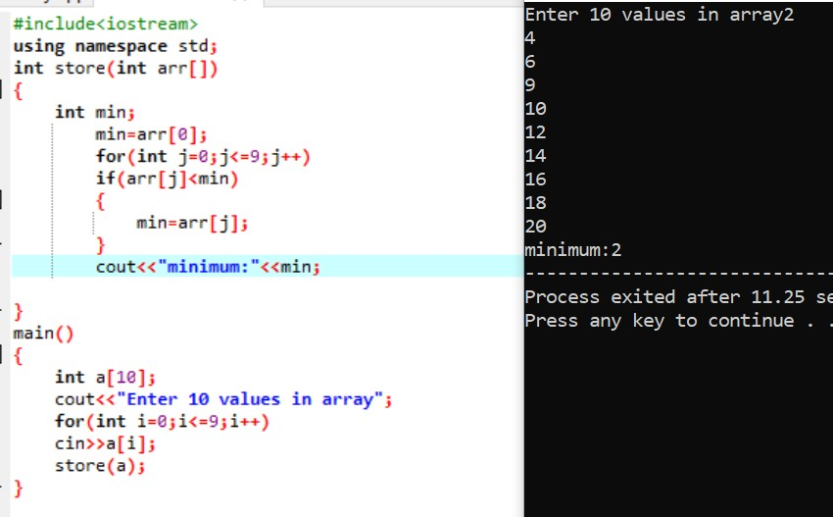

**Qno2:**Write a program that stores 10 values in array and display maximum value?

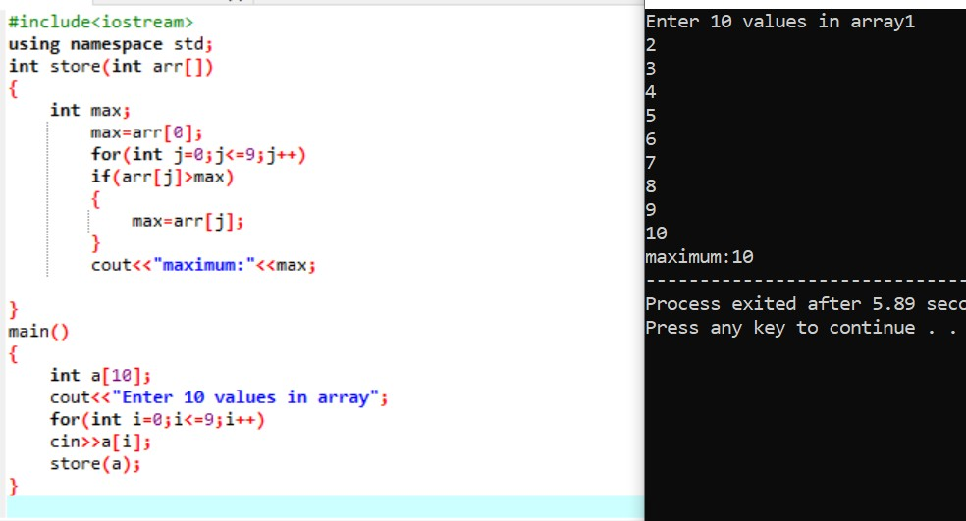

**Qno3:**Write a program that stores 10 values in array then take number from user and find that this number is present in array or not by

linear/sequential searching?

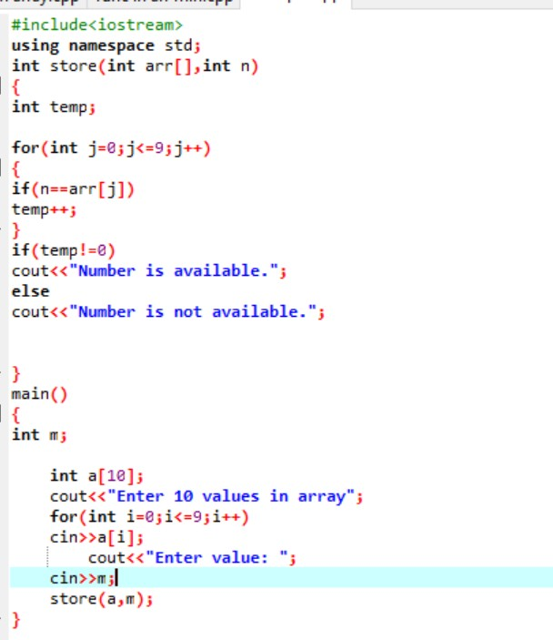

**Qno4:**Factorial using recursion function?

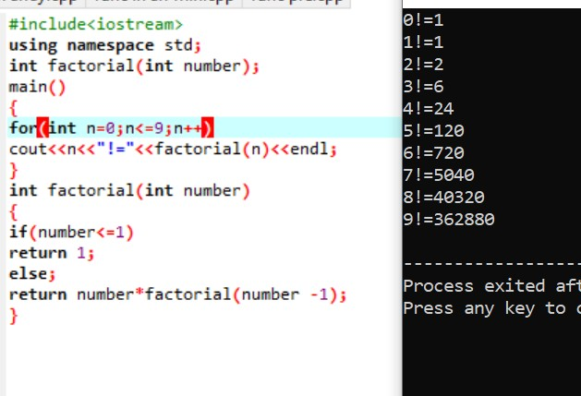

**Qno5:**Power using recursion function?

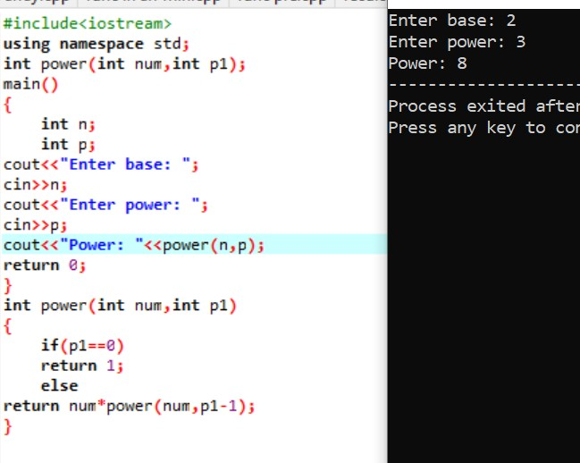

**Qno6:**Fibonacci using recursion?

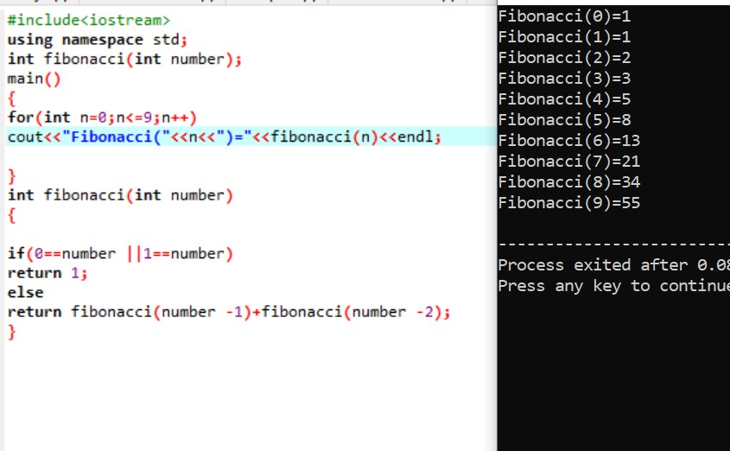

**Qno7:**Pointer example 1:

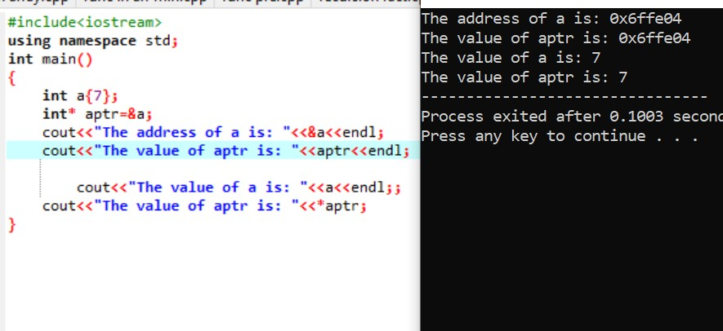

**Qno8:**Pass by value:

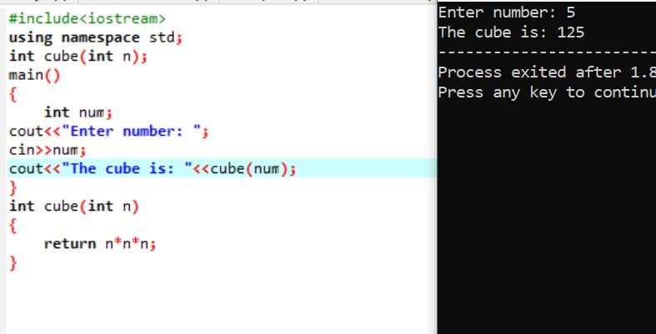

**Qno9:**Pass by reference:

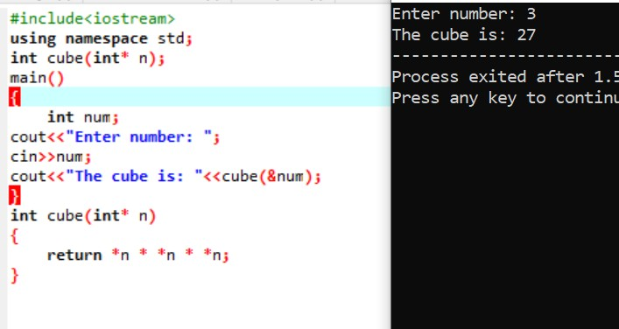

**Qno10:**Pointers with array:

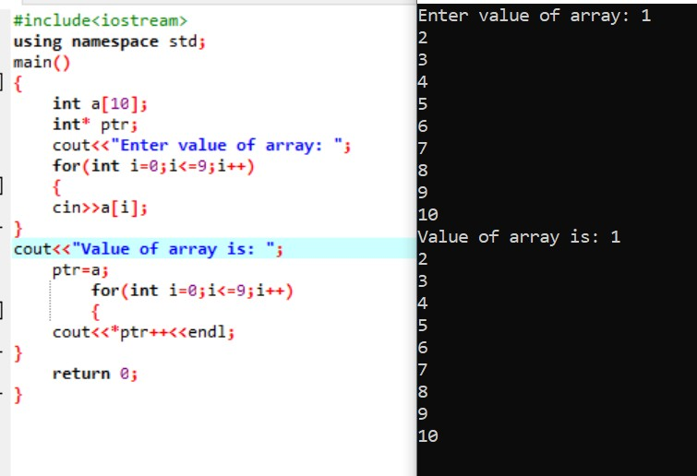

**Qno11:**Factorial using pointer:

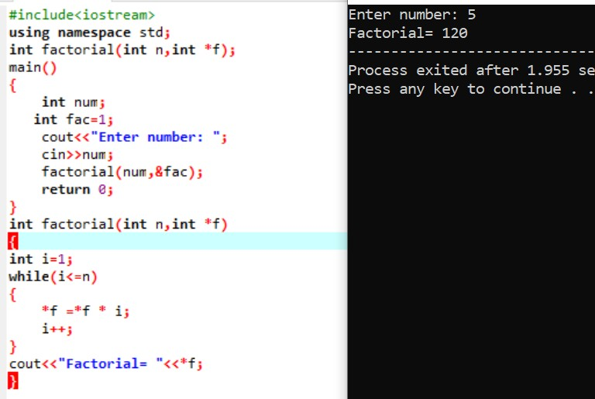

**Qno12:**Write a program that take 2 values from user and exchange their value and display on screen?

